November 12, 2024

For Immediate Release
Contact: Mike Ruzicka
414.778.4929 or 414.870.1874
mike@gmar.com

November Home Sales Up 0.4%

Highlights
- Sales Up 0.4% in November, 2.7% ahead of 2023
- Prices Up 4.3% to $394,663
- Listings Down 5.1%

November Sales
County | 2023 | 2024 | % Change
Milwaukee | 787 | 726 | -7.8%
Waukesha | 375 | 398 | 6.1%
Ozaukee | 83 | 89 | 7.2%
Washington | 92 | 130 | 41.3%
Metro Area | 1,337 | 1,343 | 0.4%
Racine | 184 | 210 | 14.1%
Kenosha | 108 | 129 | 19.4%
Walworth | 89 | 106 | 19.1%
SE WI Area | 1,718 | 1,788 | 4.1%
November Listings
County | 2023 | 2024 | % Change
Milwaukee | 860 | 832 | -3.3%
Waukesha | 314 | 288 | -8.3%
Ozaukee | 84 | 68 | -19.0%
Washington | 108 | 109 | 0.9%
Metro Area | 1,366 | 1,297 | -5.1%
Racine | 187 | 184 | -1.6%
Kenosha | 120 | 121 | 0.8%
Walworth | 122 | 112 | -8.2%
SE WI Area | 1,795 | 1,714 | -4.5%
Market Summary
Home sales in the Metropolitan Milwaukee market were up by a whisker in November, with six more home sales in November 2024 compared to the same month in 2023.

Year-to-date sales through November totaled 15,488 in 2024 versus 15,048 in 2023; a 2.7% increase.

Given that sales in 2024 have tracked close to 2023, we can safely estimate that the year will end with about 16,500 unit sales. That is essentially flat from 2023, but well below the 25,000+ units needed to meet demand.

The last time the Milwaukee market was hovering around 16,500 unit sales was when it was crawling out of the Great Recession. Of course today the regional economy is in much better shape than it was then.

Despite a performing regional economy we are not seeing sales meet demand. The primary reasons for this lag are a lack of new construction and new listings, while an increase in interest rates also plays a less significant, but noteworthy, role.

Through October there were 1,750 permits for new construction in the 4 county area. Well below the roughly 4,000 new homes and condos the market needs on an annual basis. And, although listings through November were ahead of 2023 by 5.4% (19,827 vs. 18,806, respectively), they are anemic compared to demand and historically.
Notwithstanding the dearth of construction and listings, demand for homes continues to remain strong. That demand is expressing itself in strong pricing. The average sale price in the four-county area went up 4.3% in November, from $378,371 in 2023 to $394,663 this past November.

That demand is being created by buyers who want all of the quality of life benefits that homeownership offers, so they are stretching to qualify for a loan, or come up with enough cash to get a house.


On the demand side, the market simply does not have enough homes for all the buyers who want one, resulting in prices being pushed up as buyers bid up prices.

This is a frustrating and unsustainable trend for REALTORS® trying to help buyers.
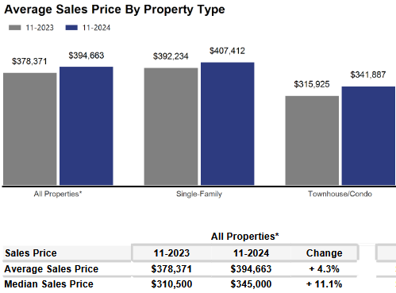
The supply of inventory on hand was only enough to satisfy 2.8 months of buyer demand in November.

If we subtract units with an offer that level drops to 1.4 months, significantly below the balanced market theory of 6 months.

As we have been highlighting for several years – REALTORS® have had an exceedingly challenging time helping home buyers find ownership opportunities in the form of condos and single-family houses.

There is a significant, long-term danger if we do not create additional supply in the form of single-family and condominium units: Thousands of would-be homeowners will be forced to stay in rental units, unable to save for a down payment and foregoing the opportunity to build wealth through a home’s equity – as well as all of the other benefits of homeownership.

That will result in problems decades down the road when families do not have enough home equity to tap into for college expenses, to remodel their home, or for emergencies.

Where to go
Buyers should seek the counsel of a REALTOR® in determining their best housing options, and sellers need a REALTORS® expert advice in making correct marketing decisions for their home.

The Greater Milwaukee Association of REALTORS® is a 5,500-member strong professional organization dedicated to providing information, services, and products to help REALTORS® help their clients buy and sell real estate. Data for this report was collected by Metro MLS, Inc. a wholly owned subsidiary of GMAR.

* Sales and Listing figures differ between the “Monthly Stats” and quarter or year-end numbers, because the collection of Monthly Stats ends on the 10th of each month, whereas quarters are a continuous tally to 12/31. For example, if a sale occurred on the 29th of the month, but an agent does not record the sale until the 5th of the next month, that sale would not be included in the sales figures of the reported month (or any subsequent month’s total) but would be added to the quarterly and annual total sales figures.

** All references to the “metropolitan” area denotes the four counties of Milwaukee, Waukesha, Ozaukee, and Washington Counties. The “region” or “Southeast Wisconsin” refers to the four metropolitan counties (Milwaukee, Waukesha, Ozaukee, and Washington), plus Racine, Kenosha, and Walworth Counties, to the south.
* * * * *

Seasonally adjusted inventory tells us how many months it would take to sell the existing homes on the market. The seasonally adjusted inventory level for November was 2.8 months. Subtracting 1,065 “active offer” listings from those available for sale (about 80% of listings with an offer sell) yields 2,998 listings, which equals 1.4 months of inventory.

With 3,910 current listings providing 2.8 months of inventory, the market would need an additional 4,407 units to push inventory to six months. Six months of inventory is considered a “balanced” market. If inventory falls below six months, the market favors sellers, and when inventory exceeds six months, it is a buyer’s market.

